

INTERNATIONAL SCHOOL OF MANAGEMENT & TECHNOLOGY

**ASSIGNMENT COVER SHEET**

|  |  |  |  |
| --- | --- | --- | --- |
| STUDENT DETAILS | | | |
|  | | | |
| Student ID |  | **Reg No.** |  |
| Family Name | DEVKOTA | **Given Name** | ANISH |
| Enrolment Year | 2020 | **Section** | L |
| Semester | FIRST | **Email** | anishdevkota@ismt.edu.np |

|  |  |  |  |  |
| --- | --- | --- | --- | --- |
| UNIT DETAILS | | | | |
| Unit Title | **Database design and development system** | **Unit Code** | **H/615/1622** | |
| Assessor Name | **Marut Dhungana** | **Issued Date** | **24th May 2021** | |
| Assignment Title | **Inventory System** | | | |
| Assignment No | **1/1** | **Submission Date** | | **9th July 2021** |
| Qualification |  | **Campus** | | **ISMT** |





**STUDENT ASSESSMENT SUBMISSION AND DECLARATION**

When submitting evidence for assessment, each student must sign a declaration confirming that the work is their own.

|  |  |  |  |
| --- | --- | --- | --- |
| Student Name | Anish devkota | Assessor Name | Marut Dhungana |
| Issue Date | 24th May 2021 | Submission Date | 9th July 2021 |
| Programme | BTECH HND leading to bsc.IT | | |
| Unit Name | Database design and development system | | |
| Assignment Title | Lotus Inc. Cosmetics | | |

**Plagiarism**

Plagiarism is a particular form of cheating. Plagiarism must be avoided at all costs and students who break the rules, however innocently, may be penalized. It is your responsibility to ensure that you understand correct referencing practices. As a university level student, you are expected to use appropriate references throughout and keep carefully detailed notes of all your sources of materials for material you have used in your work, including any material downloaded from the Internet. Please consult the relevant unit lecturer or your course tutor if you need any further advice.

**Student Declaration**

I certify that the assignment submission is entirely my own work and I fully understand the consequences of plagiarism. I understand that making a false declaration is a form of malpractice.

Student signature: Anish Devkota Date: July 9th 2021



Pearson Education 2018  
Higher Education Qualifications

Table of Contents

Part 1 5

Introduction to database 6

Database Management System 6

Relational Database Management System(RDBMS) 7

Lotus Inc. Database System 7

Determining the user requirements 7

Determining the system requirements 7

Tools used for development 7

Database design 8

ER diagram module 8

Entity 8

Attribute 8

Relationship 8

Symbols used in representing the er diagram: 9

Key and its feature 9

Primary key: 9

Foreign key: 9

Indexes 9

ER diagram of our system: 10

Data dictionary 10

Data normalization: 12

Normalization used in our Lotus INC. database system: 13

Effectiveness of design 13

Part 2 14

SQL (structured Query Language) 14

Implementation of database system 14

Joins 16

Inner join 16

Left join 17

Right join 17

Full join 18

Implementation of query language: 19

SQL query used in our database system: 19

Search statement: 25

Final application: 25

Security of database system of Lotus INC. 27

Maintenance of database system of Lotus INC. 28

Investigation of data extraction 30

Evaluation of output according to user and system requirements 30

Testing 32

Methodologies of software testing: 33

Black box testing 33

White box testing 33

Unit testing 33

Integration testing 33

Chosen testing methodology for Lotus INC 33

Test log of Lotus INC. 34

Evaluation of final database system of Lotus INC. 37

Recommendation of improvements 38

Part 3 38

Technical and user documentation 38

Lotus INC. system 38

Features of Lotus INC. system 38

Significance of Lotus INC. system 39

Limitation of Lotus INC. system 39

Risks/Constraints 39

Tools used in the Lotus INC. system 39

User guidance 39

Flowchart of Lotus INC. system 42

Improvements to be assured in future 43

Conclusion 43

References 44

# Part 1

Produce a Report:

1. The design of the relational database system using appropriate design tools and techniques.

It should contain at least four interrelated tables.

2. Clear statements of user and system requirements.

Produce a more detailed document, so you will produce a comprehensive design for a fully

functional system which will include interface and output designs, data validations and cover

data normalization and assess the effectiveness of design in relation to user and system

requirements.

**Report on**

**Database design of Lotus Inc.**

**Submitted by: Anish Devkota**

# Introduction to database

A database is the collection of data that has been arranged to make it easy to access, manage, and update. Databases build and update themselves by processing workloads, querying the data they hold, and running applications against it. A database is a logically structured collection of data that is often stored and accessed electronically through a computer system. Where databases are more complicated, formal design and modeling techniques are frequently used. A we can say database is an alphabetical arrangement of names in an address book or database that delivers information in a variety of ways.. (Guru99, 2013) The author claims that the database is a systematic collection of data that will be used in the near future. Nonetheless, databases as a personal opinion, are records of data that can be used, updated, and changed in the future using applications such as DBMS (database management system).

    Some advantages of the database are:

* It helps to access to the data quickly.
* Sharing of data will not be hard.
* Reduction in redundancy of data.
* It has query languages which makes it easier to manipulate data.
* The data will be more secured.
* Ability to store large amount of data.

   Some disadvantages of database are:

* It requires a lot of time in designing.
* The big database needs more maintenance.
* Database are very hard to design.
* The user or administrator must have a training in it.
* You have to back up your data if a database goes down.

# Database Management System

Data that is stored in a system may be updated, retrieved, or deleted using various DBMS applications. A database management system (DBMS) is a software package for defining, manipulating, retrieving, and managing data in databases. A database management system (DBMS) manipulates data, data format, field names, record structure, and file structure. It also specifies standards for validating and manipulating data. (Technopedia, 2012) According to the author, a database management system is a software program that is used to manipulate and retrieve data. Nonetheless, in my opinion, keeping data in a system for minimizing data redundancy by updating, producing, and removing data using various software packages is a good idea. MySQL, SQL Server, Oracle and FoxPro are some examples of database management systems.

# Relational Database Management System(RDBMS)

RDBMS stands for relational database management system and is a member of the database family. "RDBMS is the foundation for SQL, as well as all modern database systems such as Microsoft SQL Server, IBM DB2, Oracle, MySQL, and Microsoft Access. The relational paradigm is also used in this database management system (DBMS).” A relational database management system (RDMS) is a modern database that stores data in a relational form. Regardless, a relational database management system in our opinion is a database in which data is stored in the form of tables, columns, and rows. (tutorialspoint, n.d.).

# Lotus Inc. Database System

Herby, our task is to establish a database system for Lotus Inc. company. Study of exact user requirements was needed here for establishing the design of initial database system. We are using the relational database system for implementation of this database system. Lastly, we will now be working with the design part of our database system.

## Determining the user requirements

Herby our team worked for collecting the required facilities or activities for a user in the database system to be produced. Some of the user requirements for our project were found to be:

* System should collect a proper type of data and proper data result.
* User must be able to find the relevant data after searching by a word.
* Supplier’s details must be stored properly with the exact address and contact number.
* System must be well secured and less time in processing.
* All the product including its supplier’s data must be saved in database.
* User must be able to process the data, and be able to edit it in a table.
* Users input of data must be well secured.

## Determining the system requirements

After knowing the user requirements for our database system our team moved forward for identifying the system requirements to be fulfilled. Some requirements of system are described below:

* There must not be any sort of data redundancy.
* System should provide the enough security and data validation.
* Processing of data in our system must be less time consuming.
* System must be able to process and store the exact data provided by the user.
* Data’s in a system must be normalized and should go through different sort of testing.
* There must be separate field for separate entities and must be user friendly.
* Also there must be display of messages which conducting any task in database.

## Tools used for development

Talking about our assigned database management project following are some of the tools:

* IDE: Visual studio 2019
* C# using .Net framework
* Microsoft SQL server
* Query language
* Draw.io (for preparing ER diagram)

# Database design

After getting the information and requirements of user including system including all the tools to work with, our team moved forward for the development phase of a database. Herby we had also mentioned the tools and concepts for the process of designing our database system. Below we have described the concepts and tools for our initial relational database system.

## ER diagram module

ER diagram module is found to be the most convenient and suitable basic diagram t be followed by the database designer for ease in developing a database system. Er diagram is also called as entity relationship diagram. This diagram module represents the relation of different entities that are stored in database and related with each other. This is one of the major concept used widely in the industry area of database for implementing the conceptual database diagram. So this was the main concept used by our team for establishing the correct table and the relationship between the components of table.

As described above, ER diagram specifies the entity and relation of entities for representing a database diagrammatically and some components of the Er diagram are:

### Entity

Entity is termed as a real world object that is distinguishable from other objects. Each entity has a set of properties, the values of which will uniquely identify that thing. An entity might be concrete (for example, a person or a book) or abstract (for example, a notion) (like a holiday or a concept).

### Attribute

Attribute is determined as the components that helps in describing the real world object or an entity. For example; person id, contact number, address, etc. describes the characteristics of a person which is itself an entity.

### Relationship

Relationship is defined as the association of different entities with each other in a database. This term helps in connecting the attributes of one entity with other and helps in describing the properties together for database table. One to one relation, one to many and many to many are the common relationship used in er diagram module.

### Symbols used in representing the er diagram:

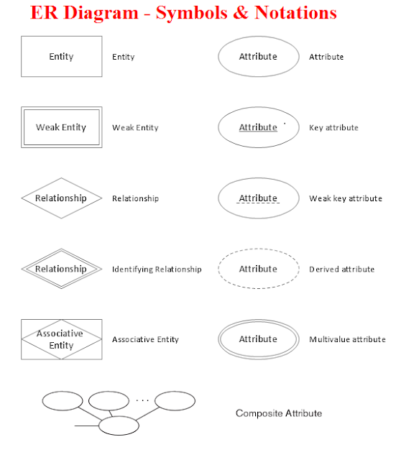

## Key and its feature

Talking about the keys in database, there are normally candidate key, primary key and foreign key.

Simply Keys aid in the identification of any data row in a table. A table in a real-world application could have thousands of records. Furthermore, the records may be duplicated. Despite these obstacles, RDBMS keys ensure that you can uniquely identify a table record. The key helps to enforce identification and integrity in the connection by allowing you to build a link between tables and identify the relationship between tables.

### Primary key:

Primary key is a table column or set of columns that uniquely identifies each row in the table. For example; Student Id uniquely describe the property of student so it is primary key. Importantly, Primary Key never accept null values.

### Foreign key:

Foreign key is a table relationship column that connects two tables. Foreign keys are used to guarantee data integrity while also allowing navigation between two different instances of the same entity. A foreign key may accept multiple null values.

## Indexes

Indexes are a powerful feature that a database uses in the background to speed up querying. All of the information needed to locate items quickly and efficiently is contained in indexes.  Indexes act as lookup tables, allowing data to be stored efficiently for faster retrieval.  Indexes are used to store table keys (codecademy, n.d.). Indexes are used in describing the flow of key and relation of different entities from one table to another.

# ER diagram of our system:

After knowing the basic functionalities of component of er module, our team then established the diagram to work with. As, ER modelling works with the top-down approach which means it lets making a diagram first and forming the entity of diagram into table. According to the scenario given to our team we had used Draw.io as a tool for designing our database system.

Below is the er diagram established by our team using draw.io:

Entity: Element, Product, Supplier, ProductElement

Relationship: product to element= many to many, supplier to element= 1 to many.

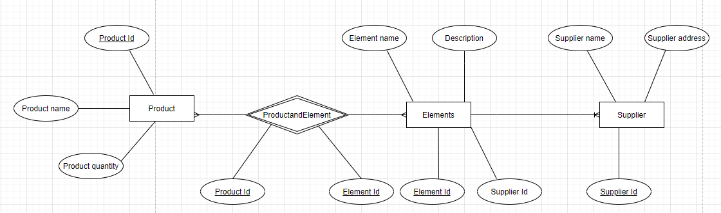

Table diagram/schema diagram designed in Microsoft SQL server by GUI:

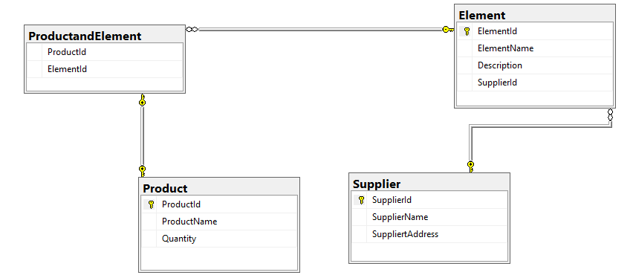

After the er diagram we then implemented the diagram to the table form and we were able to put the relationship and key in the table accordingly.

# Data dictionary

Below is the data dictionary prepared by our team for every attributes of different entities:

Supplier

|  |  |  |  |  |
| --- | --- | --- | --- | --- |
| S.N | Column Name | Data Type | Constraints | Remarks |
| 1. | SupplierId | int | Primary key | Unique Id |
| 2. | SupplierName | Varchar(10) | Not Null | Name of Supplier |
| 3. | SupplierAddress | Varchar(20) | Not Null | Address of Supplier |

product

|  |  |  |  |  |
| --- | --- | --- | --- | --- |
| S.N | Column Name | Data Type | Constraints | Remarks |
| 1. | ProductId | int | Primary key | Unique Id |
| 2. | ProductName | Varchar(20) | Not Null | Name of Product |
| 3. | Quantity | int | Not Null | Quantity of Product |

Element

|  |  |  |  |  |
| --- | --- | --- | --- | --- |
| S.N | Column Name | Data Type | Constraints | Remarks |
| 1. | ElementId | int | Primary key | Unique Id |
| 2. | Element Name | Varchar(10) | Not Null | Name of Element |
| 3. | Discription | Varchar(20) | Not Null | Discription of Product |
| 4. | SupplierId | int | Null | From Supplier |

ElementProduct

|  |  |  |  |  |
| --- | --- | --- | --- | --- |
| S.N | Column Name | Data Type | Constraints | Remarks |
| 1. | ProductId | int | Foreign Key | From Product |
| 2. | ElementId | int | Foreign Key | From Element |

Some of the procedure that are done in our designing part   
Data validation:

Data validation is the important procedure that guarantees that the data meets the required standards of quality. Data validation is the process of checking data before it is utilized in an application to ensure that it fulfills the required standards. “Data validation is a procedure that assures that data is sent to programs, applications, and services in a clean and unambiguous format. It verifies the integrity and correctness of data being entered into various software programs, as well as its composition. Data Validation guarantees that the data meets the requirements and meets the quality standards. (technopedia, 2012) Data validation, according to the author, is the process of sending clean and clear data to a computer application. Nonetheless, in my opinion, data validation in computer science is important. This also helps in managing data quality by cleansing data prior to transmission. The primary goal of data validation is to ensure that data is accurate. When migrating data from one application to another, it's important to keep it consistent. Some snapshots of data validation are given below:

Validation from user:

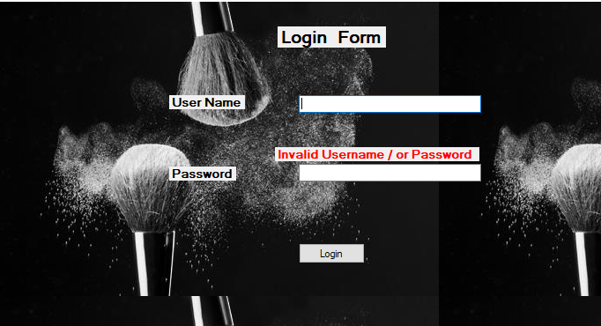

Validation from database:

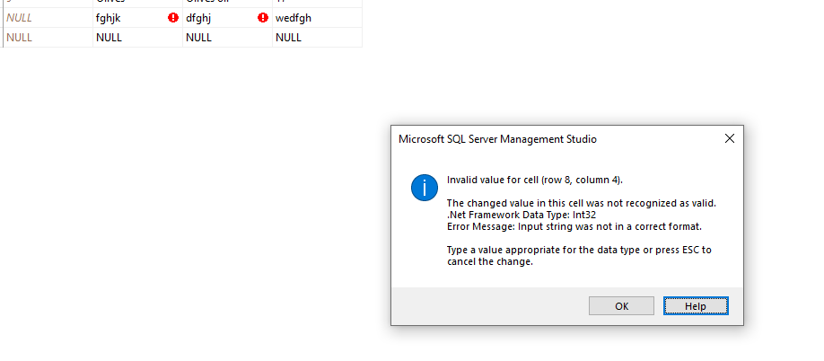

# Data normalization:

It was initially developed and introduced as an essential part of a relation model by Edgar F. Codd in 1970. It maintains, arranges and manages the data for future use accordingly. "The normalization of the database is the process of organizing data into tables so that it is always unequivocal and the results are intended. This is inherent in the theory of relational databases. It can duplicate data in the database and often lead to the creation of additional tables." (Margaret Rouse, Jack Vaughan, 2019). The processing of data in tables and arrangement of data according to the author's data normalization. In short, it is known as the normalization of data to arrange data properly or to track data in simple manner in order to reduce data redundancy. The main aim of data normalization is to maintain data management records. The most important types of data normalization are the following:

* First form of normalization(1NF)
* Second form of normalization (2NF)
* Third form of normalization (3NF)

## Normalization used in our Lotus INC. database system:

First normal form:   
Listing of a sample table in our database system in a first normal form is given below. Here we have managed to implement the first normal form of data by providing the individual data in specific rows and column.

|  |  |  |  |  |  |
| --- | --- | --- | --- | --- | --- |
| ElementId | ElementName | Discription | SupplierName | SupplierAddress | SupplierId |
| 1 | shampoo | For hair | Anish | samakhusi | 1 |
| 2 | lotion | body | akriti | tinkune | 2 |
| 7 | lipstick | lips | anisha | pepsicola | 9 |

Second normal form:

Listing of a sample table in our database system in a second normal form.

|  |  |  |  |  |
| --- | --- | --- | --- | --- |
| ElementId | ElementName | Discription | SupplierName | SupplierId |
| 1 | shampoo | For hair | Anish | 1 |
| 2 | lotion | body | akriti | 2 |
| 7 | lipstick | lips | anisha | 9 |

Third normal form:

Listing of a sample table in our database system in a second normal form.

|  |  |  |  |
| --- | --- | --- | --- |
| ElementId | ElementName | Discription | SupplierId |
| 1 | shampoo | For hair | 1 |
| 2 | lotion | body | 2 |
| 7 | lipstick | lips | 9 |

# Effectiveness of design

Talking about the design prepared by our team, we practiced focusing more on the requirements and building the system accordingly. Our design gave a proper fulfilment of a simple database system and the process to go through. Some of the effectiveness of our database design in relation to user and system requirements are listed below:

* Every entities were well developed in a separate table which made user access the needed file easily.
* By the use of proper relation and key indexes user can be able to access the required related information from another table at the same field/table.
* Data redundancy was found to be low.
* Proper data validation was done which fulfilled the requirement of getting proper data and result.
* Interface form was also designed which maintained the security and validation process of system.
* The design was mainly found to be understood to the stakeholders as well as developers for making the required system.

# Part 2

Once the designs accepted, you have to develop the database system using evidence of user

interface, output and data validations and querying across multiple tables.

You want to include more than just the basics so you will implement a fully functional

database system which will include system security and database maintenance features.

You have decided to implement a query language into the relational database system.

1. Assessing whether meaningful data has been extracted through the use of query tools to

produce appropriate management information.

2. Evaluating the effectiveness of the database solution in relation to user and system

requirements and suggest improvements.

3. Once the system has been developed, you will test the system

4. You will produce a brief report assessing the effectiveness of the testing, including an

explanation of the choice of test data used.

# SQL (structured Query Language)

SQL is the standard language in which databases are stored, manipulated and collected. It is standard language for relational database management systems, as stated in ANSI (American National Standards Institute). For the performance of activities such as updating database information or collecting database information, SQL statements are utilized. Oracle, Sybase, Microsoft SQL Server, Access, Ingres, etc. are some of the most prevalent relationship database systems using SQL. (SQLCourse.com, n.d.).

Example of SQL query: SELECT * FROM tbl_name

# Implementation of database system

After getting the normalized and well-structured design for our database system, we then moved for the development process of database and the basic database application for Lotus INC. For this process we used Microsoft SQL server and Visual studio. For the development process we have used the structured query language for forming tables and doing operations in our main database. And similarly we used C# language and SOL as for the development process of database application of Lotus INC. below are the snap shots and components we used in development process. By the help of query language, we also created and establish the table content initially.

Creating the database:

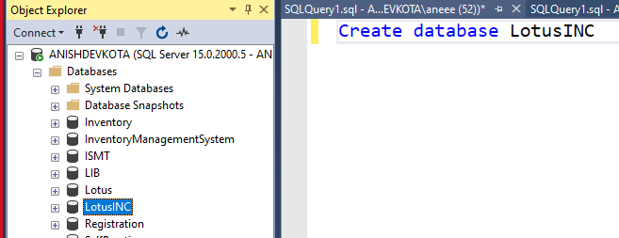

Creating table with keys for and its output:

Supplier:

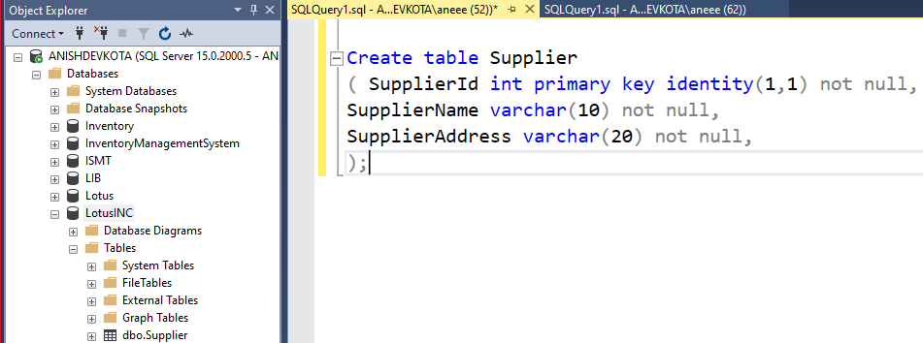

Element:

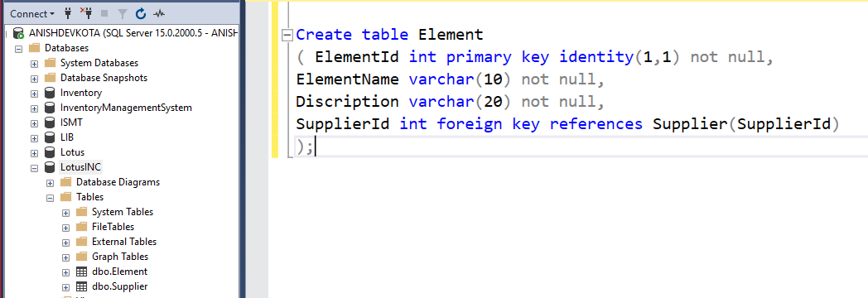

Product:

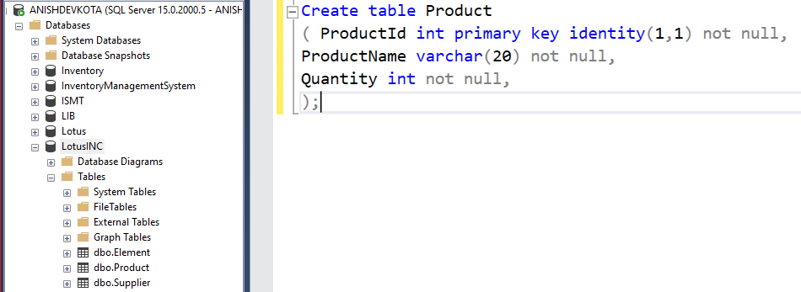

Element_ Product:

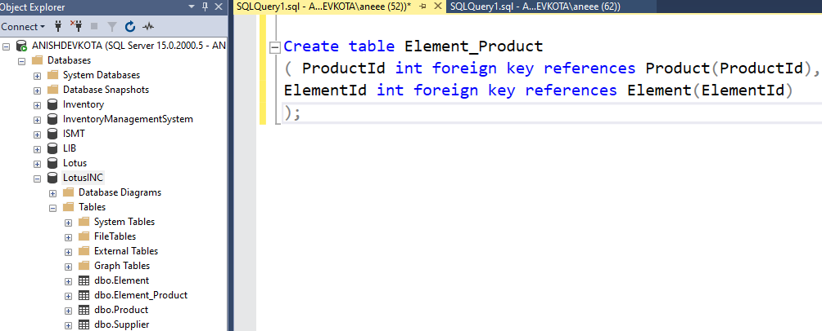

# Joins

The columns in SQL connections are combined to generate the data. Joins helps to combine different columns of the table with one table. "When rows from two or more tables are combined, a JOIN clause is used based on the column between them" (School, n.d.) According to the author, two or more tables are combined in a rows while executing the join query. In my view, it is never the less known that multiple columns are attached from several tables.

Some types of joins are:

Inner join: The record of matching values from both table is returned inside this type of join.

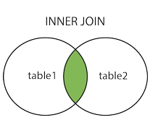

Use in our database:

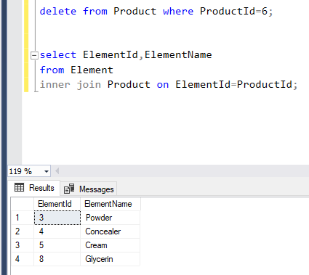0

Left join: In left join, there is a return of all the records from left outer join table and the matched record from right outer join table.

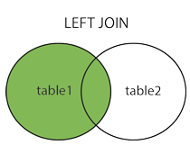

Use in our database:

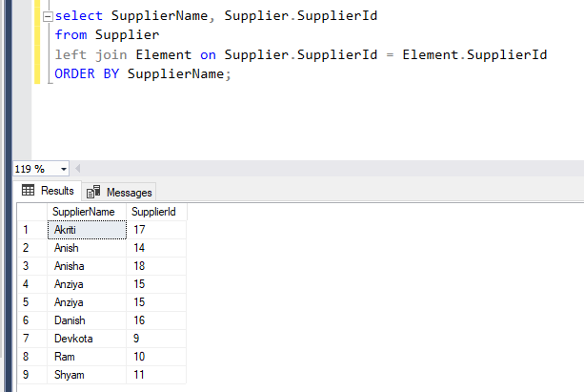

Right join: Using the right part, all rows or records from the right table with matching rows and records from the left table will be returned.

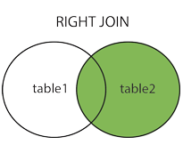

Use in our database:

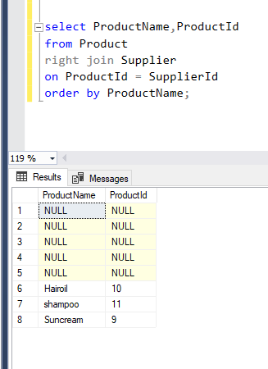

Full join: The full join is used join all the rows and records from the table along with the matching rows and records from the both right and left table. It also used to print NULL values.

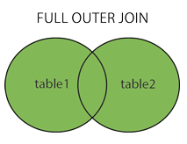

Use in our database:

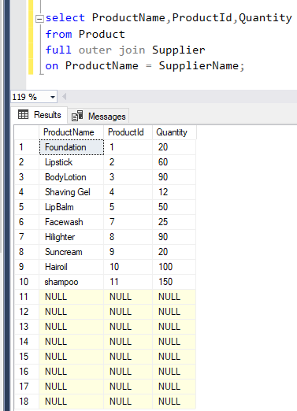

Select statement used in our database:

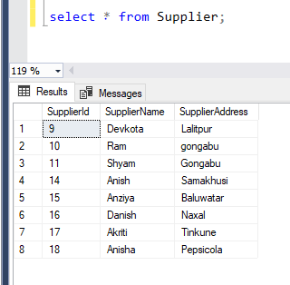

# Implementation of query language:

While development of our database system, we implemented all the query language in relational system by evaluating the SQL statements. We have used C# language along with the query language in visual studio/IDE (relational database) and help the database be connected and developed a Lotus INC. database application. Below is the screenshot evidence of querying involved in our project of Lotus INC.

## SQL query used in our database system:

Insert statement: for inserting the data in table:

In Microsoft SQL server:

Supplier:

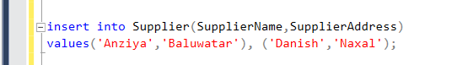

Product:

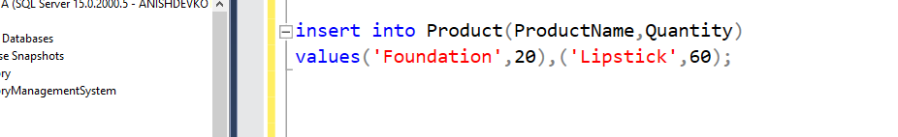

Element:



Element_Product:

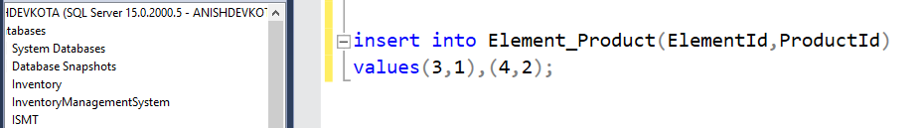

In database application:

Supplier:

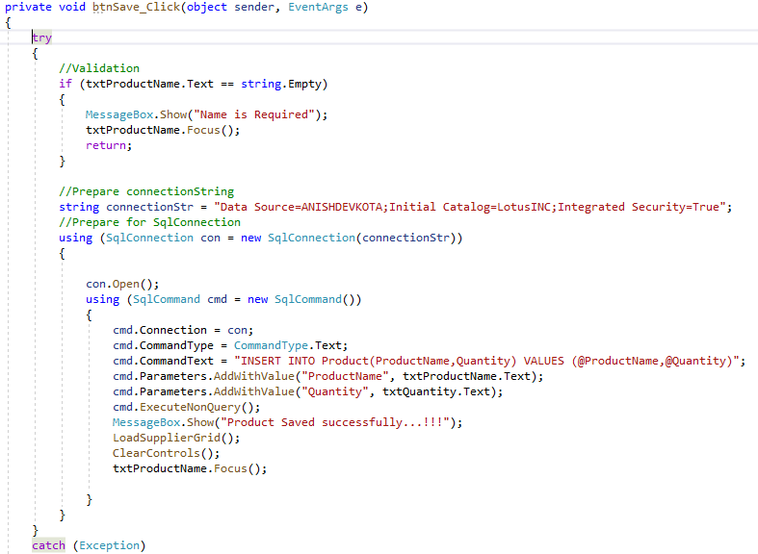

Product:

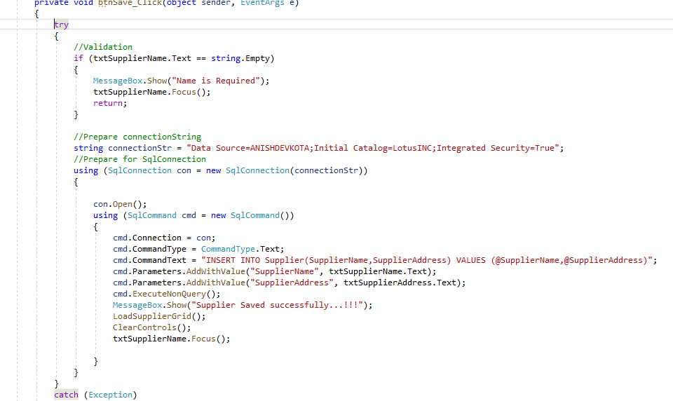

Element:

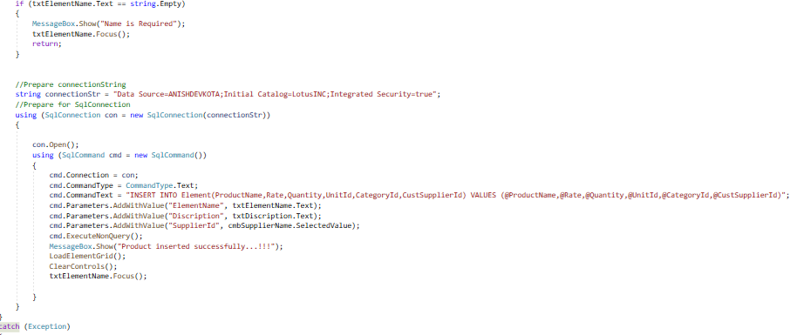

Update statement: for updating the data in table:

In Microsoft SQL server:

Supplier:

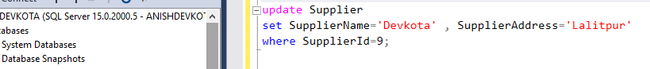

Element:

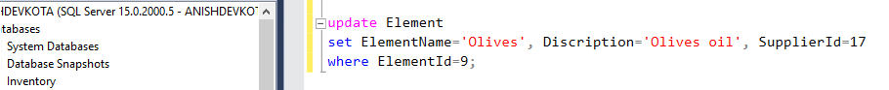

Product:

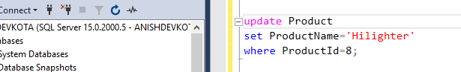

In database application:

Supplier:

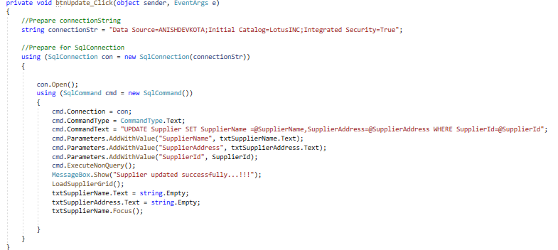

Element:

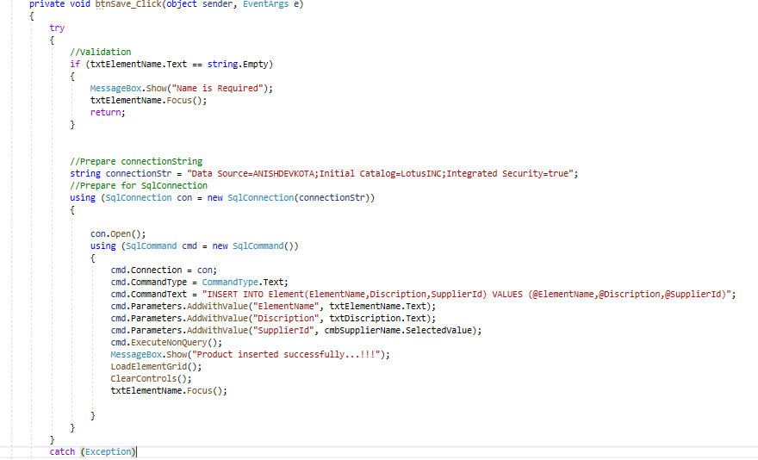

Product:

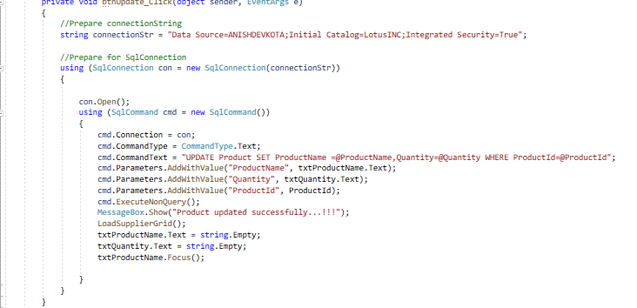

Delete statement: for deleting the data in table:

In Microsoft SQL server:



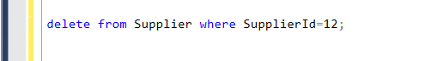

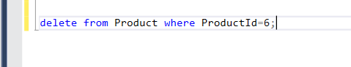

In database application:

Supplier:

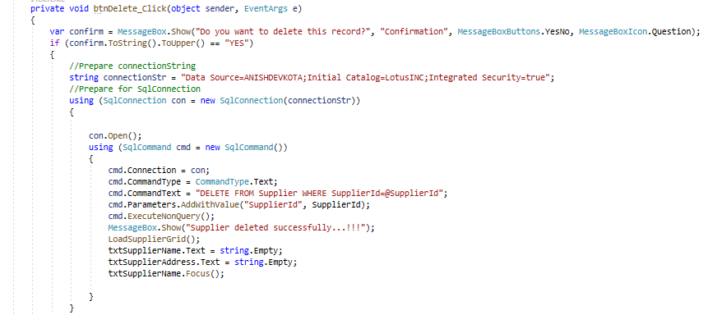

Element:

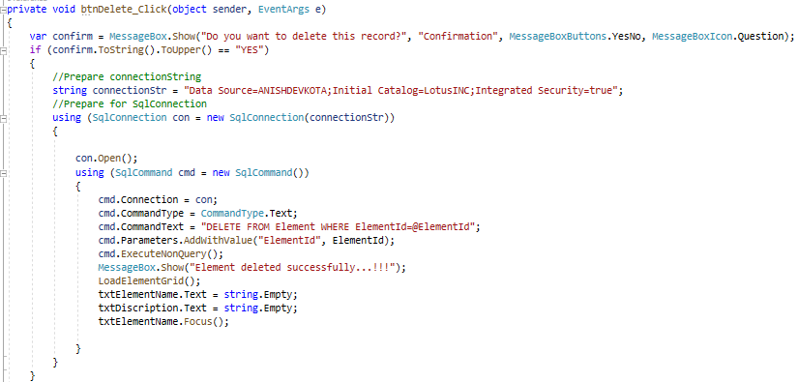

Product:

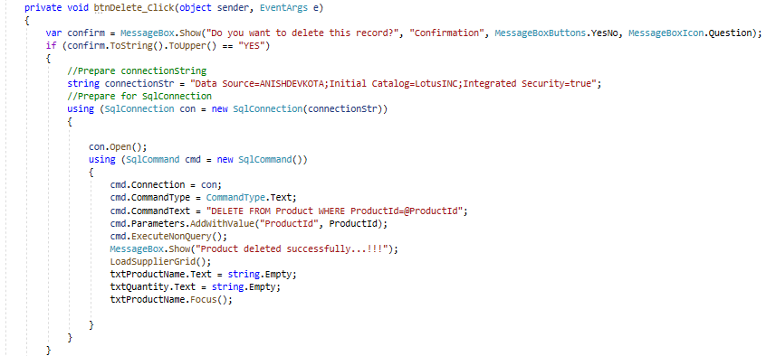

### Search statement:

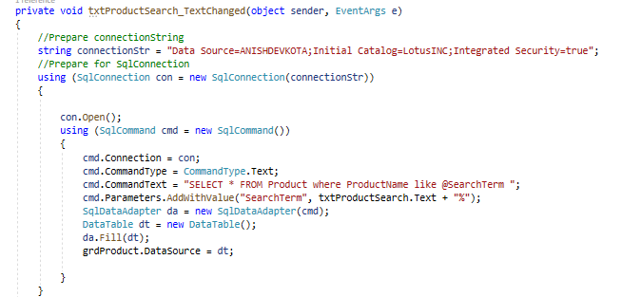

# Final application:

Below are the snapshots of the final application designed by our team:

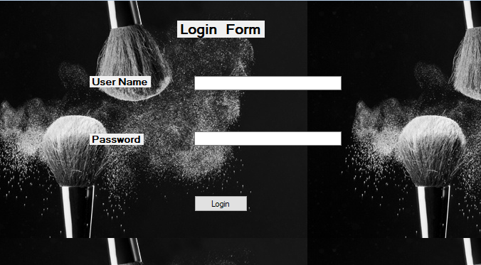

Picture: login interface for user

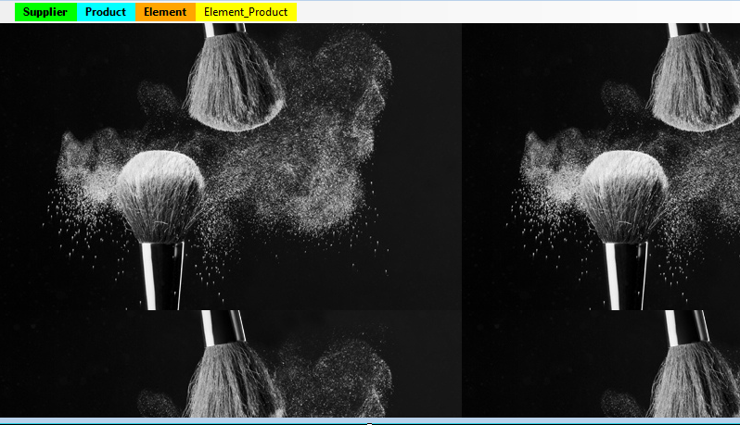

Dashboard after login.

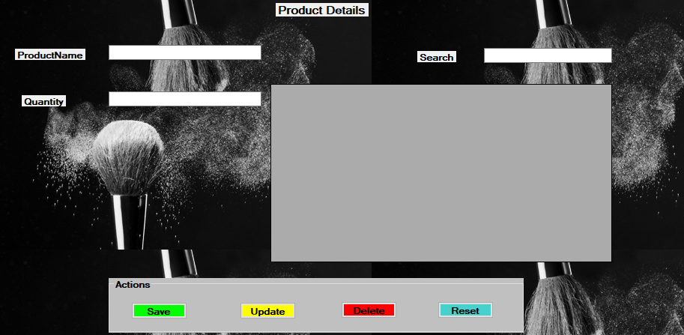

Product form after clicking product.

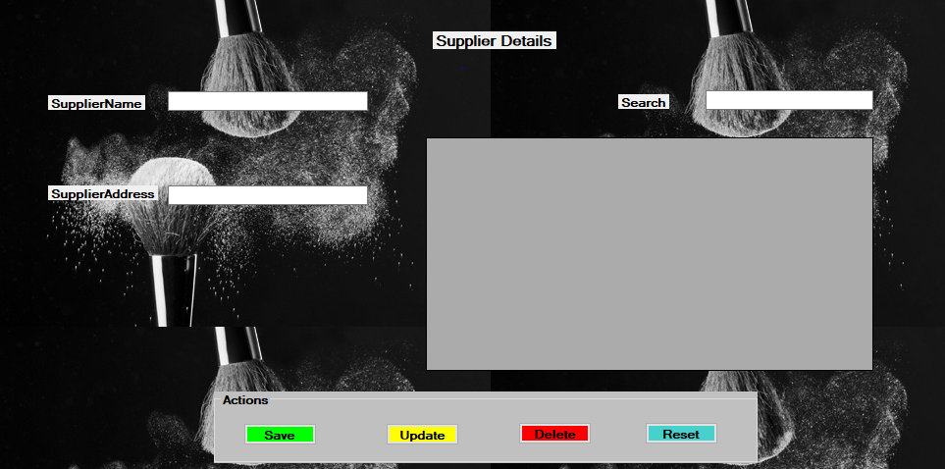

Supplier table after clicking supplier.

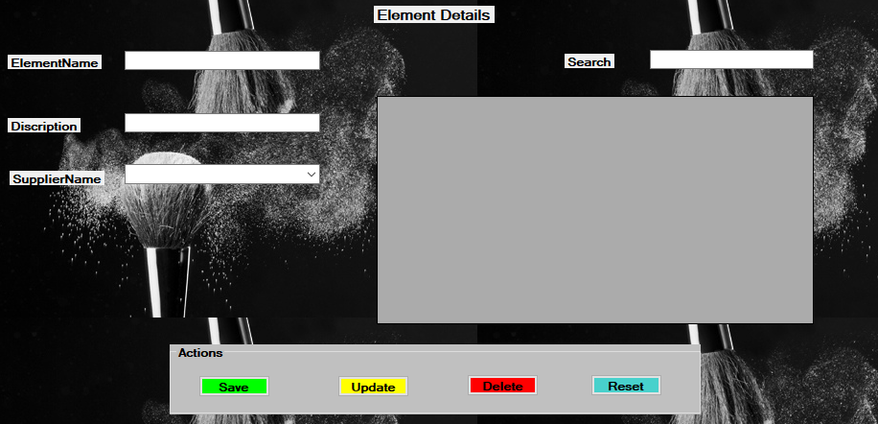

Element table after clicking on element.

# Security of database system of Lotus INC.

Therefore, as per user and system requirements our database must be well secured. Here, our team then went for the database security purpose. Our team did a great work in applying the best security to the database system that we developed. Some ways by which we made our database well secured are shown below with their purpose.



User login security provided in database.

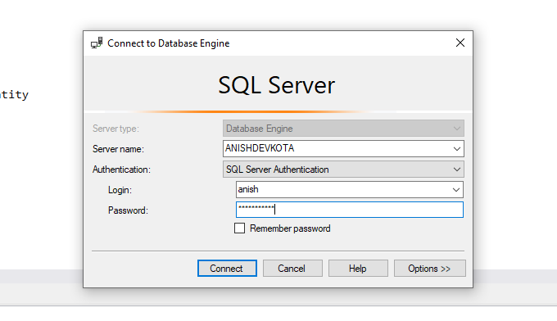

SQL server authentication for more secured database.

# Maintenance of database system of Lotus INC.

Simply in any sorts of database system, user seeks for the proper maintenance of the system. So we also have gone through different maintenance process while delivering of our database system. Some maintenance purpose done in our database system while delivering are shown below with proper snapshots.

Log file:

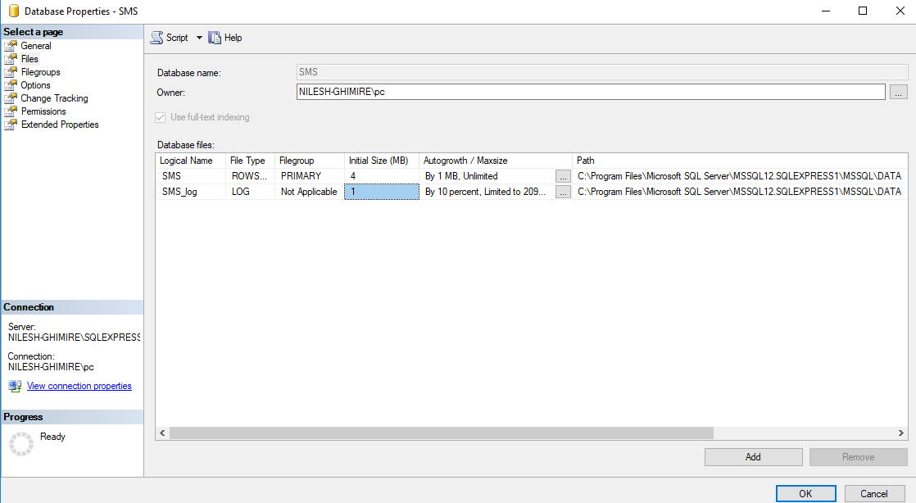

Corruption detection:

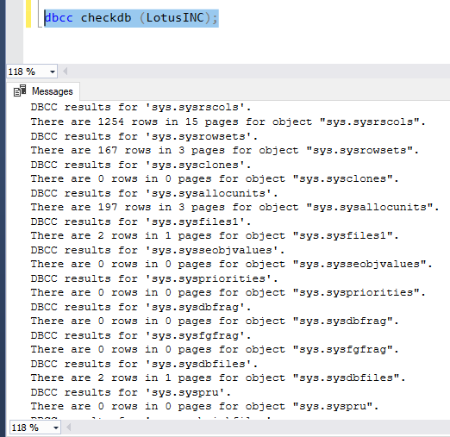

Back-up:

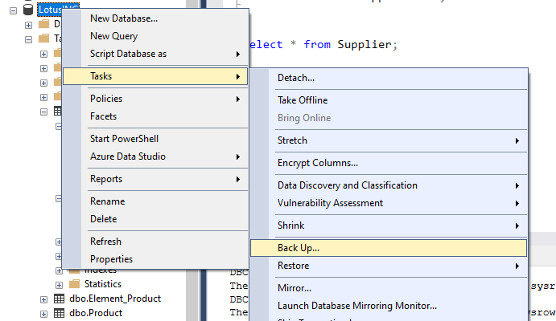

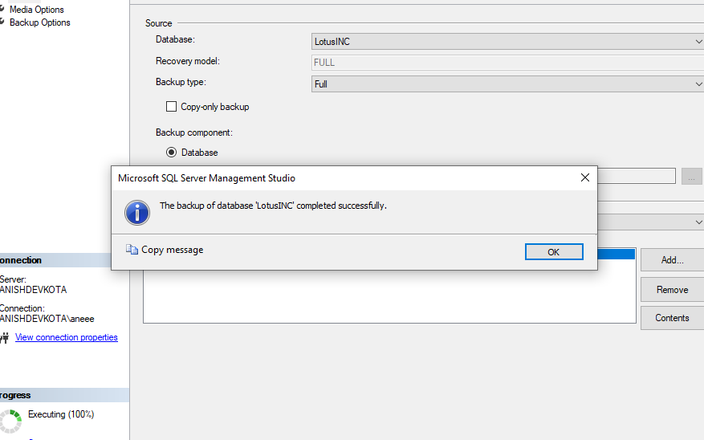

# Investigation of data extraction

After the completion of the database application development for Lotus INC. our team went through investigation of proper data extraction. Here we went through different outputs generated by the database application after processing it. We also checked for the proper data validation and working of different queried buttons used there in the database system. Some of the investigation process of our team are shown below:

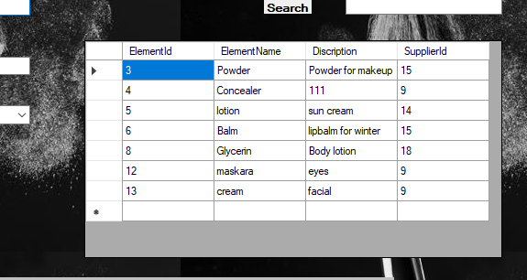

# Evaluation of output according to user and system requirements

After taking an investigation of proper data extraction we then tested our system by comparing with the user and system requirements. We compared our database with the expected result of database system and prepare an evidence of outputs generated from it.

* Storing data

Our team went through the evaluation process of storing data into database system which we prepared.

Expected: User must be able to save or store data accordingly.

Output: User was able to store data correctly in required table.

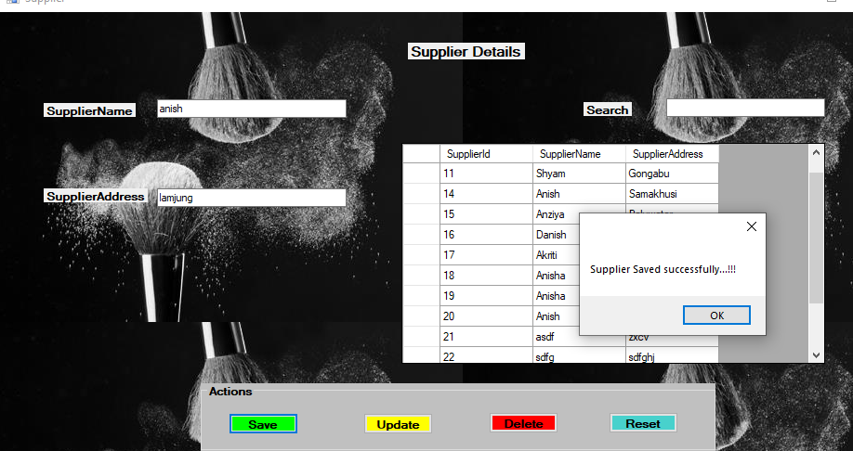

* View data

Then after according to the requirement study we tested for the search option of the database. We looked if the search option in database system is working properly or not.

Expected: After typing a text in search it must be able to show the data similar to it.

Output: The data was shown according to the user typed one.

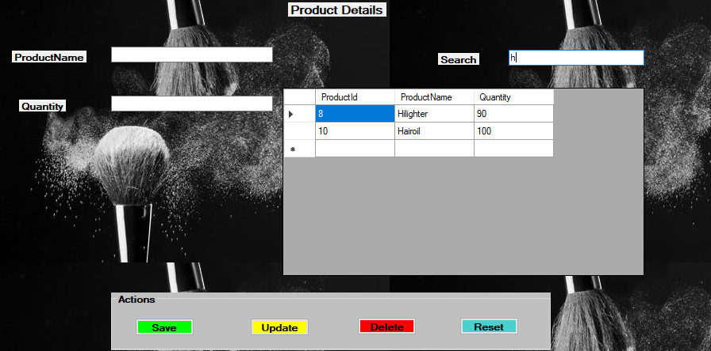

* Edit of data by user

Looking for the edit process of data in system, it was the both user and system requirement in our database system to be checked carefully.

Expected: Data operation must be done accurately and according to user’s choice.

Output: Operation like save, delete, update was able to perform perfect accordingly to user’s input choice.

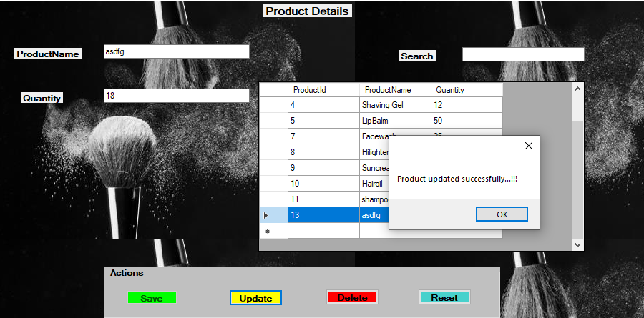

* Message box in action

Another thing to be tested by our team was about the useful message box that must be shown while operating any sort of task.

Expected: Message box must be shown for user’s confirmation in any operation

Output: Message box clearly with meaningful confirmation was shown.

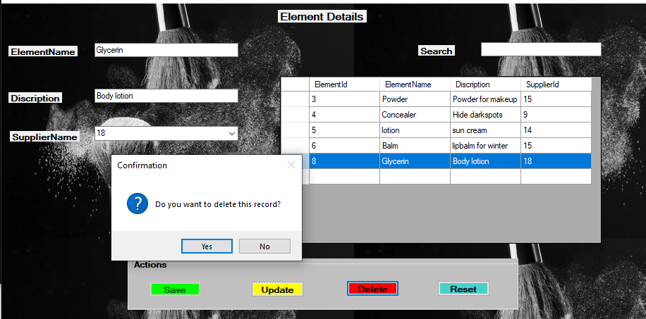

* Store data with foreign key

Another thing that we evaluated was if the foreign key in any table is well stored and exact or not.

Expected: foreign key involved in a table and data grid view of system

Output: Foreign key was displayed and stored in the data view.

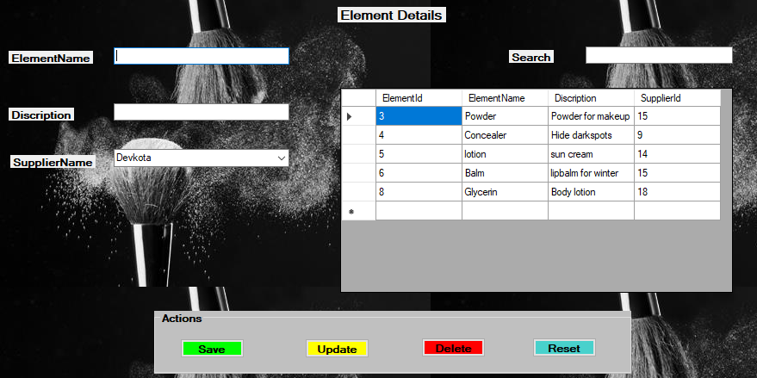

# Testing

Testing is the process of finding out how something actually works. System testing should be done before the program is transferred to the user for operation. System testing is a level of testing software where the software is tested in full and integrated form. The aim of this test is to evaluate the compliance of the system with the requirements provided. Without software testing, the program that is provided directly in the user's hand may contain numerous mistakes and defects that leave the user unfavorable impact. First of all, it is very important to properly monitor or test the system. Tests like unit tests, integration tests and stress tests have to be performed. In this procedure, even very tiny mistakes and defects need to be looked at by the testing specialists as even minor problems may occur in future that might produce a major system problem. Software testing is reasoned to examine whether the software needs have been fulfilled or not. Some things may have to be deleted and added according to requirements and these things are practiced in during this process.

## Methodologies of software testing:

### Black box testing

It is a testing approach that ignores the system or component's related concept and focuses exclusively on the outputs created in compliance with specific inputs and circumstances. The program's structure in black box is not considered. In other word we can say that this test does not test the coding structure but test for the expected outcome to be displayed at final stage. It simply examines the application's functionality also known as functional testing. In this approach, ahead to the black box testing, the tester compares the predicted performance with the actual output. This test technique comprises functional and non-functional tests without reference to the internal system structure. The following figure is shows the concept of the black box method: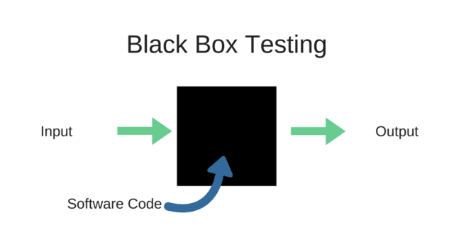

### White box testing

This test technique tester shows, unlike in a black box test, the interior structure. This is why it is termed a clear-cut check box, a glass box, a transparent checking box and structured testing. White box testing in other hand need the specific programming language for testing a software internally. This test is performed by having a look to the internal code of software and debugging it. This sort of testing is specially practiced by the software development units in organization.

### Unit testing

Unit testing is a software or application test in which an application source code, one or more application module methods are tested to see whether or not the application developed fulfills the user need. "Unit testing is a software development method where separate and independent scrutiny for correct operation of the less testable elements called units is performed. Unit tests can be performed by hand but are typically automated." (Contributor, n.d.).

### Integration testing

Integration tests are carried out to identify failures in the interaction between integrated units. Integration testing is the testing procedure between two software components or modules. The testing method in this process checks for aspects such as application performance, trustworthiness and accuracy are assessed.

# Chosen testing methodology for Lotus INC

As, being a developer of Lotus INC database system our team went through a lot of testing process. Some basic testing process done by our team are already shown above. testing and delivering a good database system without any error was the main motive for our team. During our development process we checked for all the requirements and the data extracted by performing an operation. Importantly, testing process helped us a lot in finding the errors and helped in debugging process of various mistakes in our database system. For delivering an error free database system we went through all the testing system that was clearly mentioned above with the working mechanism. Going through all the testing method was a bit time consuming but the database system which was developed by our team was to be found very reliable and accurate. Also, data redundancy was very low and processing was fast with the help of those testing approach.

Going through black box testing, we tested the final output that was delivered by system after any sort operations. We tested all the outputs that was expected by the developers and users too. By testing the output, we found some errors in display of data while updating data from a Product table in our database system. Then after we were able to correct the mistakes and make it error free. Likely all the operations were clearly checked and finalized after black box testing.

Our team before testing a system with black box approach went through the white box testing. Our database system of Lotus INC. was found to have some errors in coding structure. For dealing that error we went through deep evaluation of internal coding of database system. Being a developer our team didn’t face any big problems and importantly, IDE that we used provide us the debugging facility. And testing of coding was done efficiently and our team went through this test procedure.

Again going for a unit testing process, we tested various data validation and requirements. Here we tested if the login procedure was working successfully or not. Also checking a blank data and required data to be mentioned was checked by following this procedure. Lastly, as mentioned we went for integration testing where we tested all the components and flow of data in different forms of database system application.

Talking about the testing we organized or practiced white box testing most because for our development team it was easier in finding error and solving it. Also because of debugging facility that was provided by our chosen IDE, it was easy in resolving problems. And talking practically, coding error are the must thing to test because most of the errors in system are seen due to it. SO our team focused more on white box testing.

## Test log of Lotus INC.

* Test of user login and validation



* Test of blank space in a database form

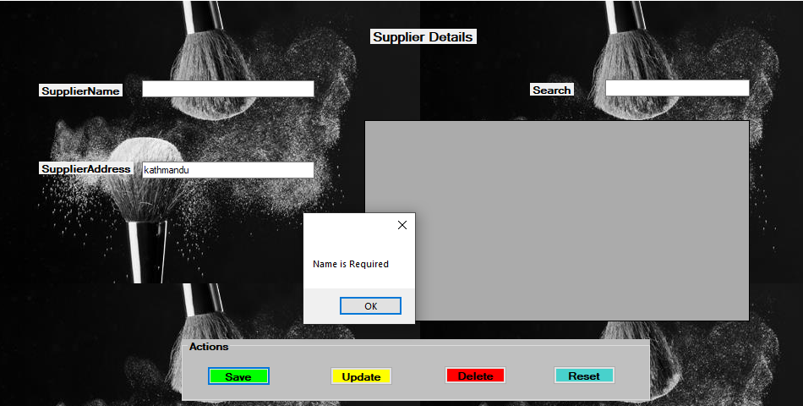

* Testing of message box for user confirmation

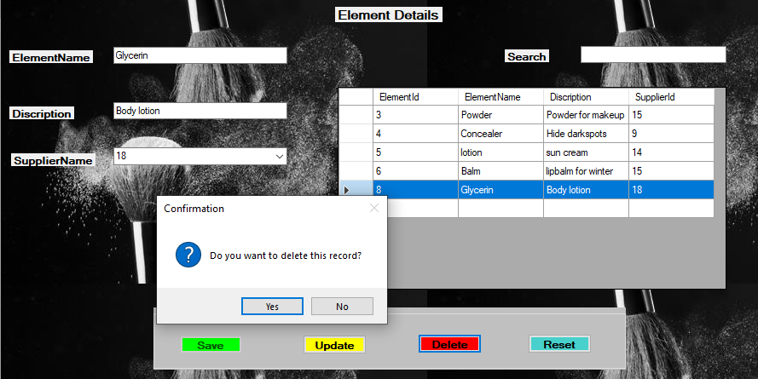

* White box test

This test was done by our team with the help of debugging facility provided by IDE.

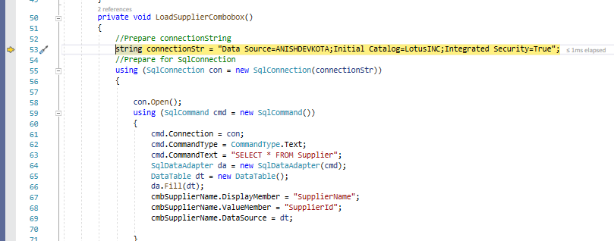

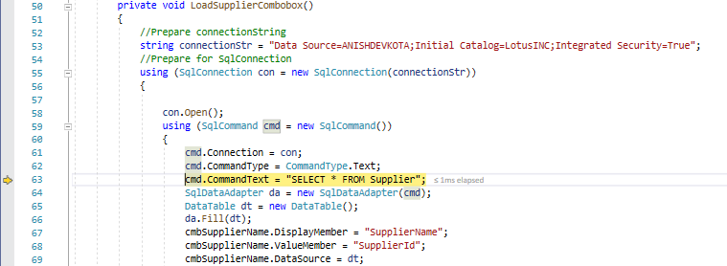

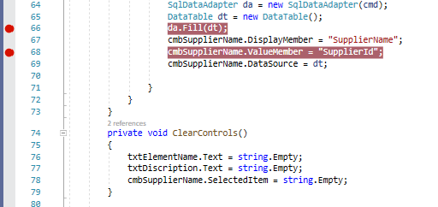

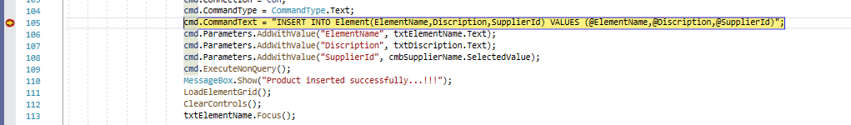

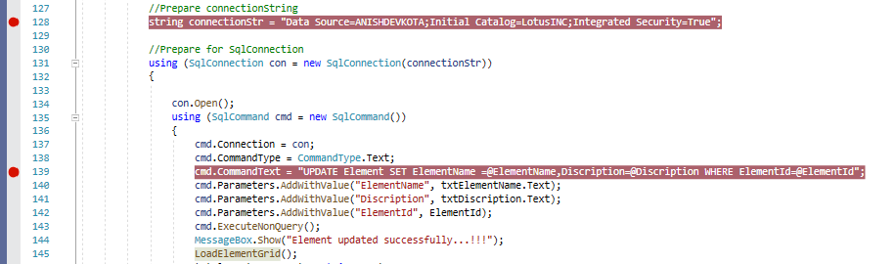

# Evaluation of final database system of Lotus INC.

After the successful completion of our Lotus Inc. database we now evaluated the database with our team members. Firstly, we found that our database system was working properly with extraction of proper data. Also the system was found to have very less redundancy and processing of any data and operations were done in a convenient way. Lots of testing and evaluation were done for finalizing the database system of Lotus INC. All the members performed the required test and operations. Also importantly, this system was found to be more secured because of certain security methods developed by our team. For example; there was login system, password procedure which made our system very secured. Timely maintenance for better performance was also done while finalizing the Lotus INC. system.

According to the system and user requirement, this database system was found to be fulfilling the requirements. Our system was also found to be more user friendlier and easier in use. All the essential data that was operated in the system was stored securely in the main database of the Lotus INC. Lotus Inc. database system also makes the data in database to find easily and authorized user can access the required data simply by searching. Also inserting, deleting and updating any sorts of data were easier and faster. Here we also configured an auto id generation facility. The Lotus INC. database system was also a low operation of database. The final database system was also found to be fulfilling all the user as well as system requirements as mentioned before. Although there were some constraints like; Users cannot access the program that are not mentioned in user information. The program can only be accessed by those having a relevant password or login requirements. If user forgets password mistakenly, that will be hard to find because password is kept encrypted in the database. The database system was good at processing but was suitable only for small scale industry. Backup of database is not stored in cloud form, so any problem in database system may hamper the whole application and all data may get lost.

Therefore, our Lotus INC. database system was found to be well working and well fulfilling the demand of user and system to be. As, some improvements can also be done in the future accordingly for updated database system. By fulfilling the requirements and all the testing procedure the final Lotus INC. database system was ready for the delivering process. All the test and evaluation were very helpful in ensuring the quality of Lotus INC. database system.

# Recommendation of improvements

After completion of the database system of Lotus INC. there are few areas of improvements in a system. Some of the things to be improved that are suggested by our team are:

* Password can be made in encrypted form and decrypted for the main administrators.
* Registration facility of new user can be added to the database application.
* There must be use of stored procedure of registration for saving the new data of new user in a database system.
* Certain calculation of products sell and purchase can be added to the database system
* Making a separate report containing all data might be helpful in collecting all the data flow in Lotus INC. separately.
* Upgrading the system according to the technology is also equally recommended by our team.
* Maintenance facility can be provided for maintaining and checking the data stored in Lotus INC. system.

# Part 3

Lastly you will produce technical and user documentation.

You want to provide some graphical representations for ease of reference in the technical guide, so you have decided to produce a technical and user documentation for a fully functional system, including diagrams showing movement of data through the system, and flowcharts describing how the system works.

# Technical and user documentation

## Lotus INC. system

Lotus INC. system is an important database system establish by the team of ISMT college for the data storing and executing process. Lotus INC. is a company that produces the cosmetic products and the Lotus INC. system provide the information about flow of data and changes in data of the company. The main functionality of this system is to store the information of different suppliers and products required for the company. This system also helps in analyzing the data and flow of market by the help of data operation. This database system also will be helpful in storing a file or information of company securely and electronically. Also for the convenient and effective data storing method this system is established. This database system also captures the relevant information for the company.

## Features of Lotus INC. system

* User friendly
* Maximum performance
* Low cost operation
* Secured system
* Suitable for the small scale industry
* Data can be accessed easily by search method
* Encrypted form of password for making secure database
* Id generation is automatic

## Significance of Lotus INC. system

* Users may feel of high performance of work
* Data stored can be seen in an application as well
* There must be a proper user validation
* Easy in doing operation like insert, delete, update of data
* Maintenance is estimated to be low budgeted

## Limitation of Lotus INC. system

* No proper backups for database
* Although being secured there is not enough security policy
* Integer types are fixed
* Product increased or decreased are not automatically done
* Adding new user can only be done from the database and not from application because of not registration service given.

## Risks/Constraints

Application development process are very difficult to complete without being free of bugs and problems. Each application also contains its own constraints or risk. Some risks involved in the database system of Lotus INC. are:

* Validate user: Users cannot access the program that are not mentioned in user information. The program can only be accessed by those having a relevant password or login requirements. If user forgets password mistakenly, that will be hard to find because password is kept encrypted in the database.
* No backup: Backup of database is not stored in cloud form, so any problem in database

system may hamper the whole application and all data may get lost.

* Integer types: Due to use of fixed integer in database, if user enters other kinds of valued data or integers then application creates problem.
* Doesn’t suits large industry: These application only meets the criteria and fulfil the standards for small organization, incase used in large company it cannot meets the standards for them.

## Tools used in the Lotus INC. system

Below are the main tools used for the development process of Lotus INC. database system:

* IDE: VisualStudio-2019 community edition
* Programming language: C# using .Net Framework
* Relational Database Management System: Microsoft SQL server
* Platform: Desktop application

User guidance:

Step1: Run the application and login with valid username and password:



Step2: Choose any required field you want to get data from:



Step3: Inserting data in a table with confirmation message and result



Step4: Updating the data in table with confirmation message and result



Step5: Deleting data from table with confirmation message and result



Step6: Use of search button with confirmation message and result



Step7: display of wanted data with confirmation message and result

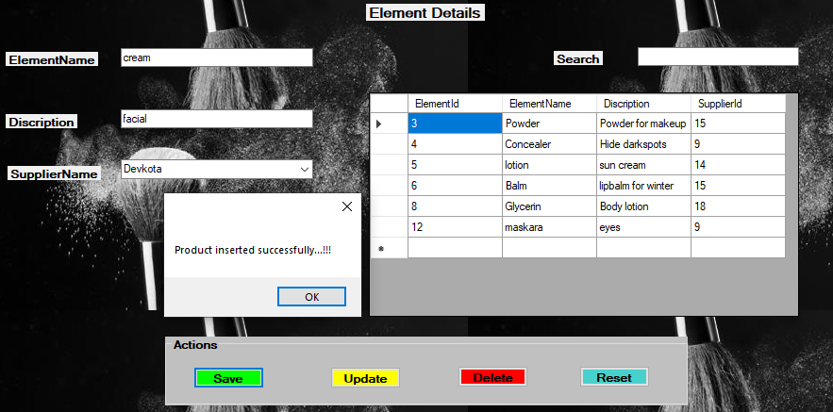

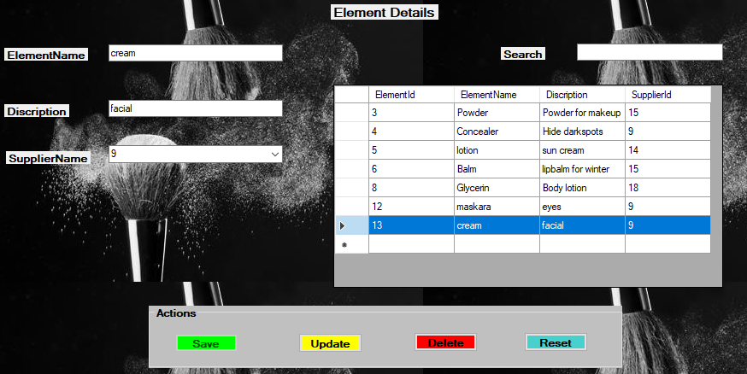

## Flowchart of Lotus INC. system

Basically, the flowchart represent how operation are performed or working mechanism of any applications or algorithms. SO below is the flow chart of Lotus INC. describing the working mechanism diagrammatically.

**Lotus INC system**

Login

**Dashboard**

**Supplier**

**Product**

**Element**

**Element_Product**

## Improvements to be assured in future

As application system must be improved or changed according to the new technology. So some of the future improvements that can be assured for better database system of Lotus INC. are listed below:

* Strong security policy like face detector or biometric login can be implemented to the system
* Calculation of the pricing and taking out the final audit report can be the important process in the database system
* System should be upgraded to the large industry based performing system according to the development of company or organization
* Registration of new applicants can be implemented from application rather that inserting new one to database
* Password forget facility with proper confirmation can be implemented into the system.

# Conclusion

Above is the full detail of all snapshots and the systematic way of development of database system. Following this systematic process one can get a good grasp of steps included in preparing the fully functional database system. Also our project was completed by doing different sort of testing and evaluating process. This helped our team in providing the proper and accurate required data to the users.

# References

*codecademy*. (n.d.). Retrieved from codecadmy.com: https://www.codecademy.com/articles/sql-indexes

Contributor, T. (n.d.). *SearchSoftwareQuality*. Retrieved from www.searchsoftwarequality.com: https://searchsoftwarequality.techtarget.com/definiti

Guru99. (2013). *Guru99*. Retrieved from guru99.com: https://www.guru99.com/introduction-to-database-sql.html

Margaret Rouse, Jack Vaughan. (2019, september). *SearchSqlServer*. Retrieved from www.SearchSqlServer.com: https://searchsqlserver.techtarget.com/definition/normalization

School, W. (n.d.). *W3 school*. Retrieved from www.W3 school.com: https://www.w3schools.com/sql/sql_join.asp

*SQLCourse.com*. (n.d.). Retrieved from www.sqlcourse.com: http://www.sqlcourse.com/intro.html

*Technopedia*. (2012). Retrieved from technopedia.com: https://www.techopedia.com/definition/24361/database-management-systems-dbms

technopedia. (2012). *technopedia*. Retrieved from www.technopedia.com: https://www.techopedia.com/definition/10283/data-validation#:~:text=Explains%20Data%20Validation-,What%20Does%20Data%20Validation%20Mean%3F,different%20software%20and%20its%20components.

*tutorialspoint*. (n.d.). Retrieved from tutorialspoint.com: https://www.tutorialspoint.com/sql/sql-rdbms-concepts.htm